# Logging in to Naviance (Staff and Students)

## Go to https://launchpad.classlink.com/cbsd

1. 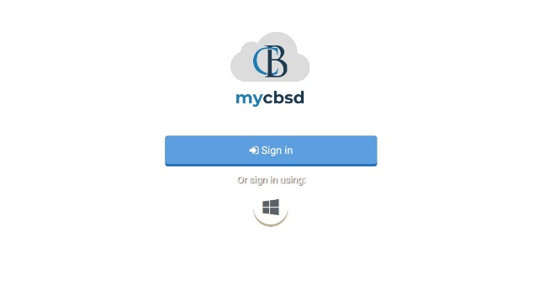Click the **Sign In button**
2. Enter your @CBSD.org staff email address, and password and click **Sign In**
3. Click on the **Naviance Icon**

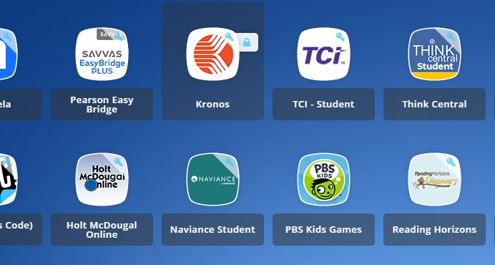

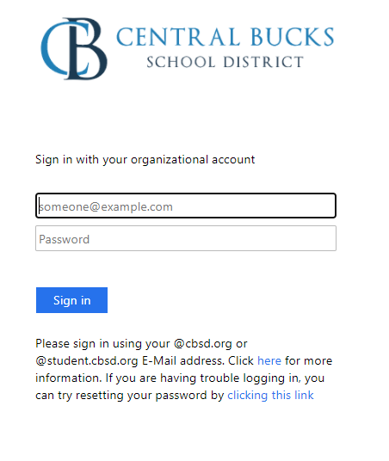You will then be logged into Naviance.

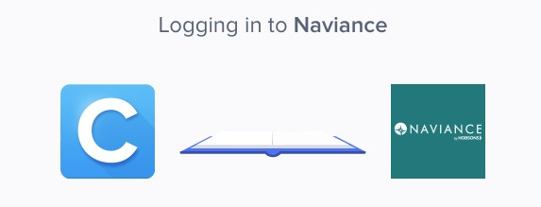



Twelfth Grade Scope and Sequence

# Build, Update, or Finalize Resume

1. From your Naviance Student homepage, click **My Planner** and then **Tasks** in the top right corner.

1. From the Task page, click the task titled **Build Resume.**
2. Locate the “completion trigger” in the top

right corner indicated by the pink arrow.



1. Click the text, **build a resume** to go to the Resume Builder tool.
2. On the Resume Builder page, click the pink circle and white arrow to add a section to your resume.



You can add experiences from the following areas:

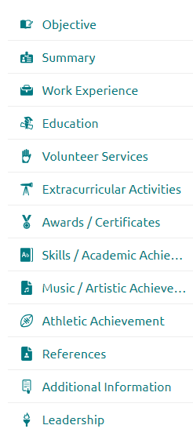

1. Add your information into the resume area you selected. When you are finished with each section click **Add.**
2. Once you’ve added all the sections you would like in this draft of your resume, click **Print/Export Resume** at the top of the screen.



1. Clicking the same pink circle and white arrow icon, add a resume draft. Name your draft and select a resume template.

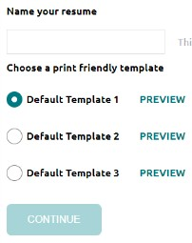

1. Select the resume sections you’d like to include in your draft using the check boxes. When complete click **Save Resume.**
2. A completed draft of your resume marks the task as complete.

# Financial Literacy Reflection Survey

1. From your Naviance Student homepage, click **My Planner** and then **Tasks** in the top right corner. Graphical user interface, website

   Description automatically generated
   1. Locate the “completion trigger” in the top

right corner indicated by the pink arrow.



* 1. Click the text, **complete the Financial Literacy Reflection Survey** to go to the survey page

1. From the Task page, click the task titled

## Financial Literacy Reflection Survey.

1. Read the task description or use the links here to watch financial tutorial videos:
2. <http://www.youcandealwithit.com/borrowers/student-aid-> [101/index.shtml.](https://nam02.safelinks.protection.outlook.com/?url=http%3A%2F%2Fwww.youcandealwithit.com%2Fborrowers%2Fstudent-aid-101%2Findex.shtml&amp;data=02%7C01%7Cvbarrett%40cbsd.org%7C271f4549c7a74c45f78508d84f469c62%7Caa0b488ffc9e4185a5e3384220df23ca%7C0%7C0%7C637346511974195911&amp;sdata=dG6LSiTaRndY7bsQmNxqiU%2BknFWEbFvns%2BMtIyujEKQ%3D&amp;reserved=0)
3. <https://www.consumerfinance.gov/paying-for-college/choose-a-> [student-loan/#o1](https://nam02.safelinks.protection.outlook.com/?url=https%3A%2F%2Fwww.consumerfinance.gov%2Fpaying-for-college%2Fchoose-a-student-loan%2F%23o1&amp;data=02%7C01%7Cvbarrett%40cbsd.org%7C271f4549c7a74c45f78508d84f469c62%7Caa0b488ffc9e4185a5e3384220df23ca%7C0%7C0%7C637346511974205910&amp;sdata=frBPwD%2FspSsGSLZa0y0fghJHZ%2FHtta7MZk0WGstutmU%3D&amp;reserved=0)

- Also download the “[action guide](https://nam02.safelinks.protection.outlook.com/?url=https%3A%2F%2Ffiles.consumerfinance.gov%2Ff%2Floan.pdf&amp;data=02%7C01%7Cvbarrett%40cbsd.org%7C271f4549c7a74c45f78508d84f469c62%7Caa0b488ffc9e4185a5e3384220df23ca%7C0%7C0%7C637346511974215900&amp;sdata=3bRdTmcom1lKG3WOQ0hVdRg8ZT7n6e5mMrTjDPmuup4%3D&amp;reserved=0)”

1. [http://www.educationplanner.org/students/paying-for-](http://www.educationplanner.org/students/paying-for-%20) [school/student-aid-checklists/high-school.shtml](https://nam02.safelinks.protection.outlook.com/?url=http%3A%2F%2Fwww.educationplanner.org%2Fstudents%2Fpaying-for-school%2Fstudent-aid-checklists%2Fhigh-school.shtml&amp;data=02%7C01%7Cvbarrett%40cbsd.org%7C271f4549c7a74c45f78508d84f469c62%7Caa0b488ffc9e4185a5e3384220df23ca%7C0%7C0%7C637346511974215900&amp;sdata=JYbuG%2BxbOI2D4dlKB2CRcAWaaMXQJHf%2FeQBJUvfoxdE%3D&amp;reserved=0)
2. Once you have answered all of the required questions (marked by an asterisk and in red) click “Submit Answers” at the bottom of the page



1. Submitting the survey will mark the task as complete.

# Senior Survey

1. From your Naviance Student homepage, click **My Planner** and then **Tasks** in the top right corner.

1. From the Task page, click the task titled

## Senior Survey.

1. Locate the “completion trigger” in the top

right corner indicated by the pink arrow

1. Click the text, **complete the Senior Survey**

to go to the survey page.

1. Once you have answered all of the required questions (marked by an asterisk and in red) click “Submit Answers” at the bottom of the page.



1. Submitting the survey will mark the task as complete.

